Scenario 1: Process monthly interest for all savings accounts (1%).
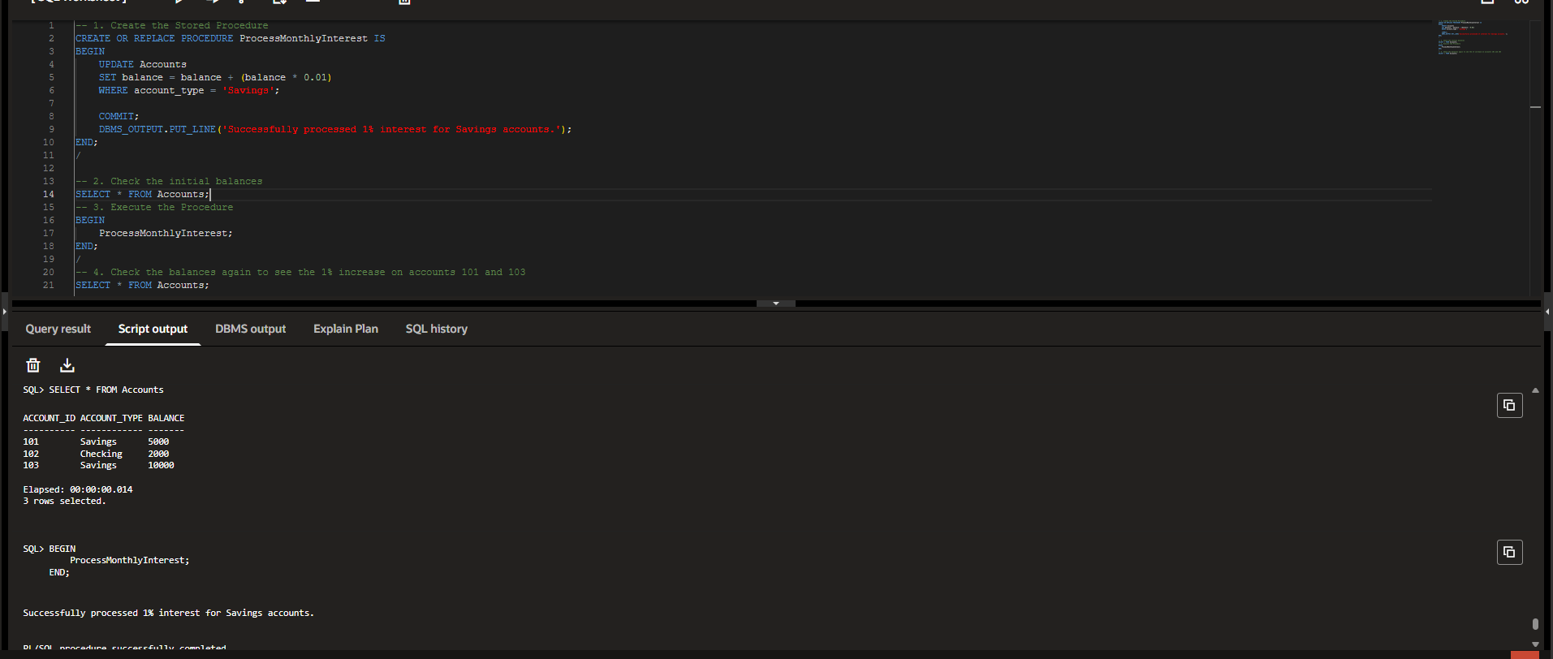
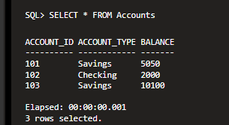
Code:
-- 1. Create the Stored Procedure
CREATE OR REPLACE PROCEDURE ProcessMonthlyInterest IS
BEGIN
UPDATE Accounts
SET balance = balance + (balance * 0.01)
WHERE account_type = 'Savings';

COMMIT;
DBMS_OUTPUT.PUT_LINE('Successfully processed 1% interest for Savings accounts.');
END;
/

-- 2. Check the initial balances
SELECT * FROM Accounts;

-- 3. Execute the Procedure
BEGIN
ProcessMonthlyInterest;
END;
/

-- 4. Check the balances again to see the 1% increase on accounts 101 and 103
SELECT * FROM Accounts;

Scenario 2: Implement a bonus scheme for employees based on department.
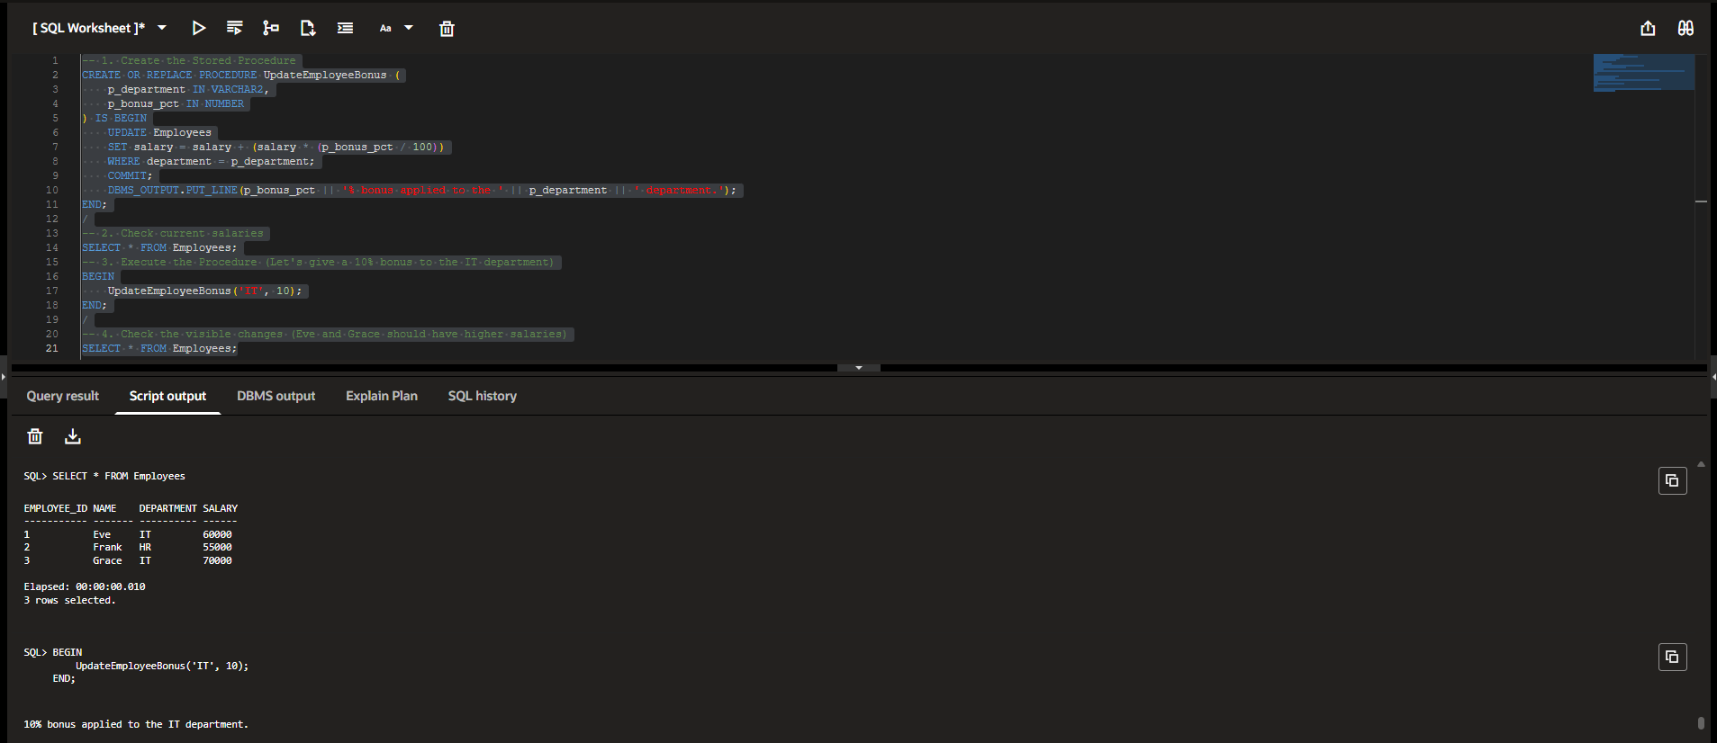
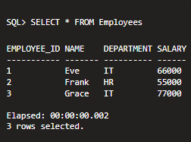
Code:
-- 1. Create the Stored Procedure
CREATE OR REPLACE PROCEDURE UpdateEmployeeBonus (
p_department IN VARCHAR2,
p_bonus_pct IN NUMBER
) IS
BEGIN
-- Update salary by adding the percentage passed in the parameters
UPDATE Employees
SET salary = salary + (salary * (p_bonus_pct / 100))
WHERE department = p_department;

COMMIT;
DBMS_OUTPUT.PUT_LINE(p_bonus_pct || '% bonus applied to the ' || p_department || ' department.');
END;
/

-- 2. Check current salaries
SELECT * FROM Employees;

-- 3. Execute the Procedure (Let's give a 10% bonus to the IT department)
BEGIN
UpdateEmployeeBonus('IT', 10);
END;
/

-- 4. Check the visible changes (Eve and Grace should have higher salaries)
SELECT * FROM Employees;

Scenario 3: Transfer funds between accounts with a balance check. 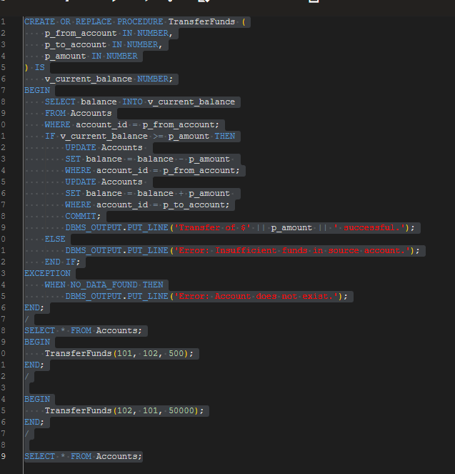
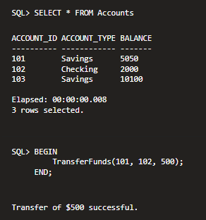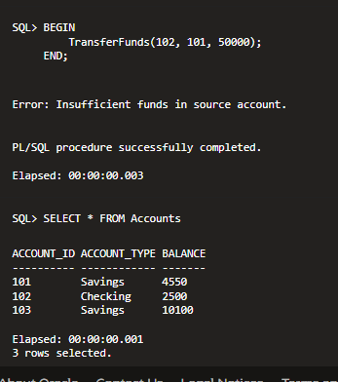
Code:
-- 1. Create the Stored Procedure
CREATE OR REPLACE PROCEDURE TransferFunds (
p_from_account IN NUMBER,
p_to_account IN NUMBER,
p_amount IN NUMBER
) IS
v_current_balance NUMBER;
BEGIN
-- Get the current balance of the source account
SELECT balance INTO v_current_balance
FROM Accounts
WHERE account_id = p_from_account;

-- Check if they have enough funds
IF v_current_balance >= p_amount THEN
-- Deduct from the sender
UPDATE Accounts
SET balance = balance - p_amount
WHERE account_id = p_from_account;

-- Add to the receiver
UPDATE Accounts
SET balance = balance + p_amount
WHERE account_id = p_to_account;

COMMIT;
DBMS_OUTPUT.PUT_LINE('Transfer of $' || p_amount || ' successful.');
ELSE
DBMS_OUTPUT.PUT_LINE('Error: Insufficient funds in source account.');
END IF;

EXCEPTION
-- Catch the error if someone types in a fake account ID
WHEN NO_DATA_FOUND THEN
DBMS_OUTPUT.PUT_LINE('Error: Account does not exist.');
END;
/

-- 2. Check the initial balances
SELECT * FROM Accounts;

-- 3. Execute a valid transfer ($500 from Account 101 to Account 102)
BEGIN
TransferFunds(101, 102, 500);
END;
/

-- 4. Execute an invalid transfer (Trying to send $50,000 from Account 102 to 101)
BEGIN
TransferFunds(102, 101, 50000);
END;
/

-- 5. Verify the final account balances
SELECT * FROM Accounts;

